**Group 3 ETL Process: Order Fulfillment**

# Package.dtsx

# DateDimImport.dtsx

# Stage_OrderFufillment.dtsx

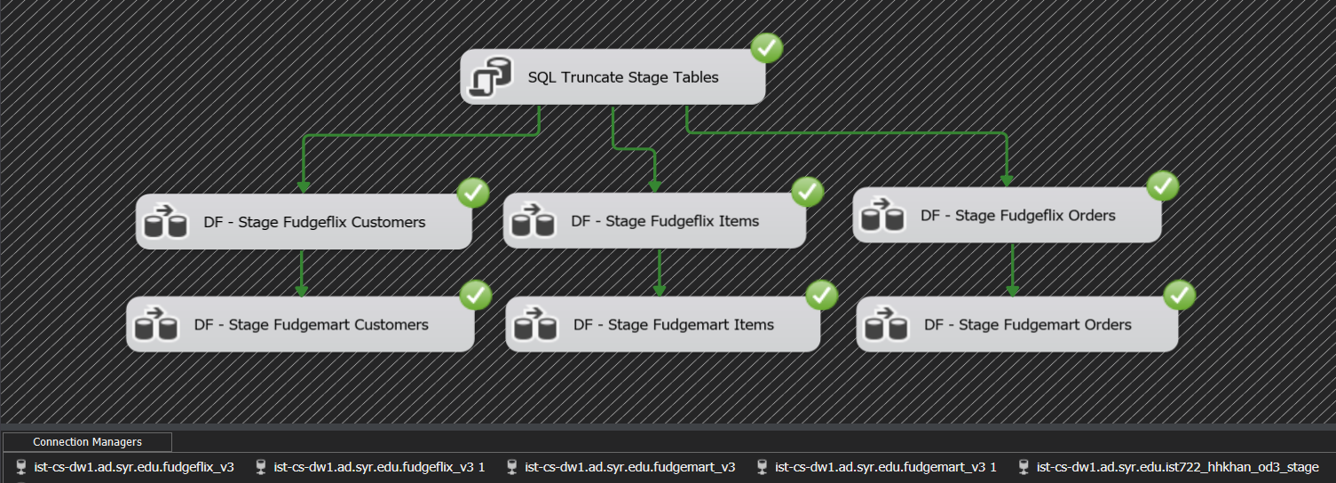

# Stage to DimCustomer (Ran previously, which is why there are 0 new rows)

# Stage to DimItems (Ran previously, which is why there are 0 new rows)

# Stage to DimOrders (Ran previously, which is why there are 0 new rows)

# Stage to FactOrderFufillment (Ran previously, which is why there are 0 new rows)

# DW_OrderFufillment.dtsx

# Assumptions

1. Nulls replaced with ‘NA’
2. Null dates replaced with date for DateKey equal to -1
3. Lagged time measure created from using DateDiff of OrderDate and ShippedDate